Tour Bus Production Process

A tour bus company makes tour buses – the kind used for concert tours or other traveling shows. The basic bus is purchased from the manufacturer and is customized in a two-stage production process.

At the body work stage (the “bodyshop”), the interior of the bus is customized, including the fitting of sleeping rooms, lounge areas, and a kitchen and modifying the window arrangement. Each bus receives about the same bodywork, and this takes 10 working days.

The bus then is moved to a painting area (the “paintshop”), where it is painted. The paintwork on these tour buses is usually quite spectacular, including individual artwork, as well as a high-quality overall finish. The time taken to paint a bus average 10 days, but is highly variable; sometimes the paint “wrinkles” and has to be redone. In a few cases, painting can be accomplished in 2 days, but there have been instances in which a bus took 18 days to paint satisfactorily. The painting time can be approximated by an uniform distribution U[2, 18].

“Raw” buses can be stored in a large lot outside. There is always a bus for the bodyshop to work on. Painted buses are weatherproof and can be stored outside, so the paintshop can always unload a finished bus. However, buses that are ready for painting must be kept inside, and the only place available is the bodyshop. If bodywork employees finish a bus, but painting employees are busy, then the bodyshop is “blocked”; work must stop until painting finishes and the bus can be moved into the paintshop. If painting employees finish a bus, they can begin work on the next bus only if the bodyshop has finished bus ready; otherwise, they are “starved” and must wait for the bodyshop to finish a bus before they can start work again.

Managers have noticed that the bodyshop often is blocked and the paintshop often is idle, with no bus to paint. The suggestion has been made that a floor space large enough to park one complete fitted but unpainted bus should be created between the two processes. Bodywork employees would then be able to “unload” a complete fitted bus into this space even though painting employees were still busy. Similarly, painting would sometimes be able to start a new bus if one was available in storage, even though the bodyshop employees were still working.

1. Model the existing system

If the painting times required by the first 4 buses are 17, 11, 6, and 14 days respectively, how would you simulate the current production process? Assume painting starts on the day after the bodywork is finished. The first bus starts the bodywork at the beginning of Day 1.
 | A | B | C | D | E
Bus  Number | Start  Bodywork  at the beginning of Day | End  Bodywork at the end of Day | Start  Painting at the beginning of Day | Painting  Time | Finish  Painting at the end of Day
1 | 1 | 10 | 11 | 17 | 27
2 | 11 | 20 | 28 | 11 | 38
3 | 28 | 37 | 39 | 6 | 44
4 | 39 | 48 | 49 | 14 | 62

2. Model the proposed system

If the painting times required by the first 4 buses are 17, 11, 6, and 14 days respectively, how would you simulate the proposed production process?
 | A | B | C | D | E | F
Bus  Number | Start  Bodywork at the beginning of Day | End  Bodywork at the end of Day | Into Waiting the beginning of Day | Into  Painting the beginning of Day | Painting  Time | Finish  Painting at the end of Day
1 | 1 | 10 | 11 | 11 | 17 | 27
2 | 11 | 20 | 21 | 28 | 11 | 38
3 | 21 | 30 | 31 | 39 | 6 | 44
4 | 31 | 40 | 41 | 45 | 14 | 58

Build a spreadsheet model to show how the additional storage space improves the productivity.
Simulation for the existing production system

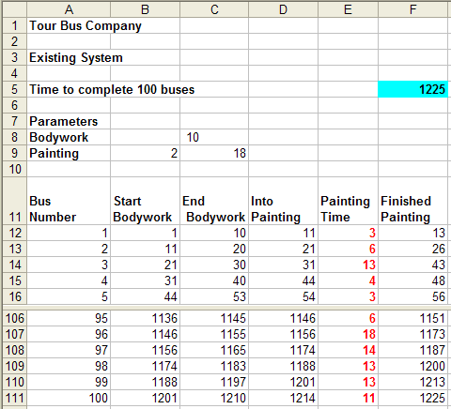

Cell | Formula | Copy to
B12 | 1
C12 | B12 + $C$8-1 | C13:C111
D12 | C12 +1
E12 | RANDBETWEEN($B$9:$C$9) | E13:E111
F12 | D12+E12 -1 | F13:F111
B13 | D12 | B14:B111
D13 | Max(C13, F12) +1 | D14:D111

Simulation for the proposed system

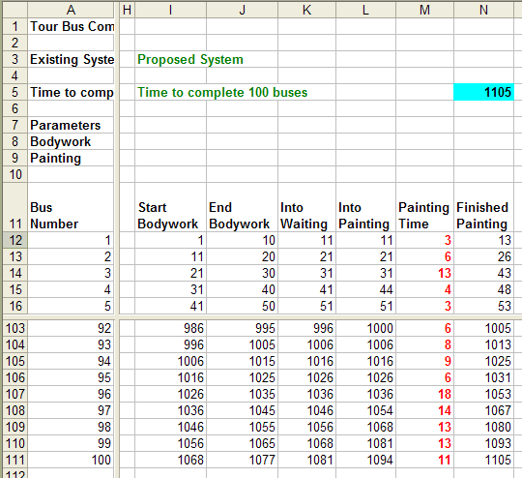

Cell | Formula | Copy to
I12 | 1
J12 | I12+$C$8 -1 | J13:J111
K12 | J12 +1
L12 | K12
M12 | E12 | M13:M111
N12 | L12+M12 -1 | N13:N111
I13 | K12 | I14:I111
K13 | MAX(J13+1,L12) | K14:K111
L13 | MAX(N12 +1, K13) | L14:L111

Calculate the time difference of completing 100 buses:

Q5=F5-N5

Run 200 simulation runs and record the value of Q5 in Data Table. Calculate the Summary Statistics of the 200 runs:

Summary Statistics of the time difference of completing 100 buses
Mean | 129.195
Std. dev | 13.13888
min | 90
max | 160

98% confidence interval of the mean time difference is: [129.20 ± 2.326×13.14/√200]=[127.03, 131.36]

